Southern Roots
Riders Club

“God-Family-Country”

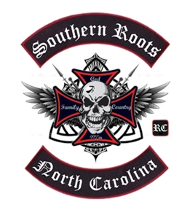

Come join the CLUB!

Contact Jamie C. Grigg II
@ 704-913-9023
For more information

Monthly Meetings…

No Membership Fees or Monthly Dues

*Organized Rides
*Community Involvement
*Charity Events
*Bike Rallies

And alot more!

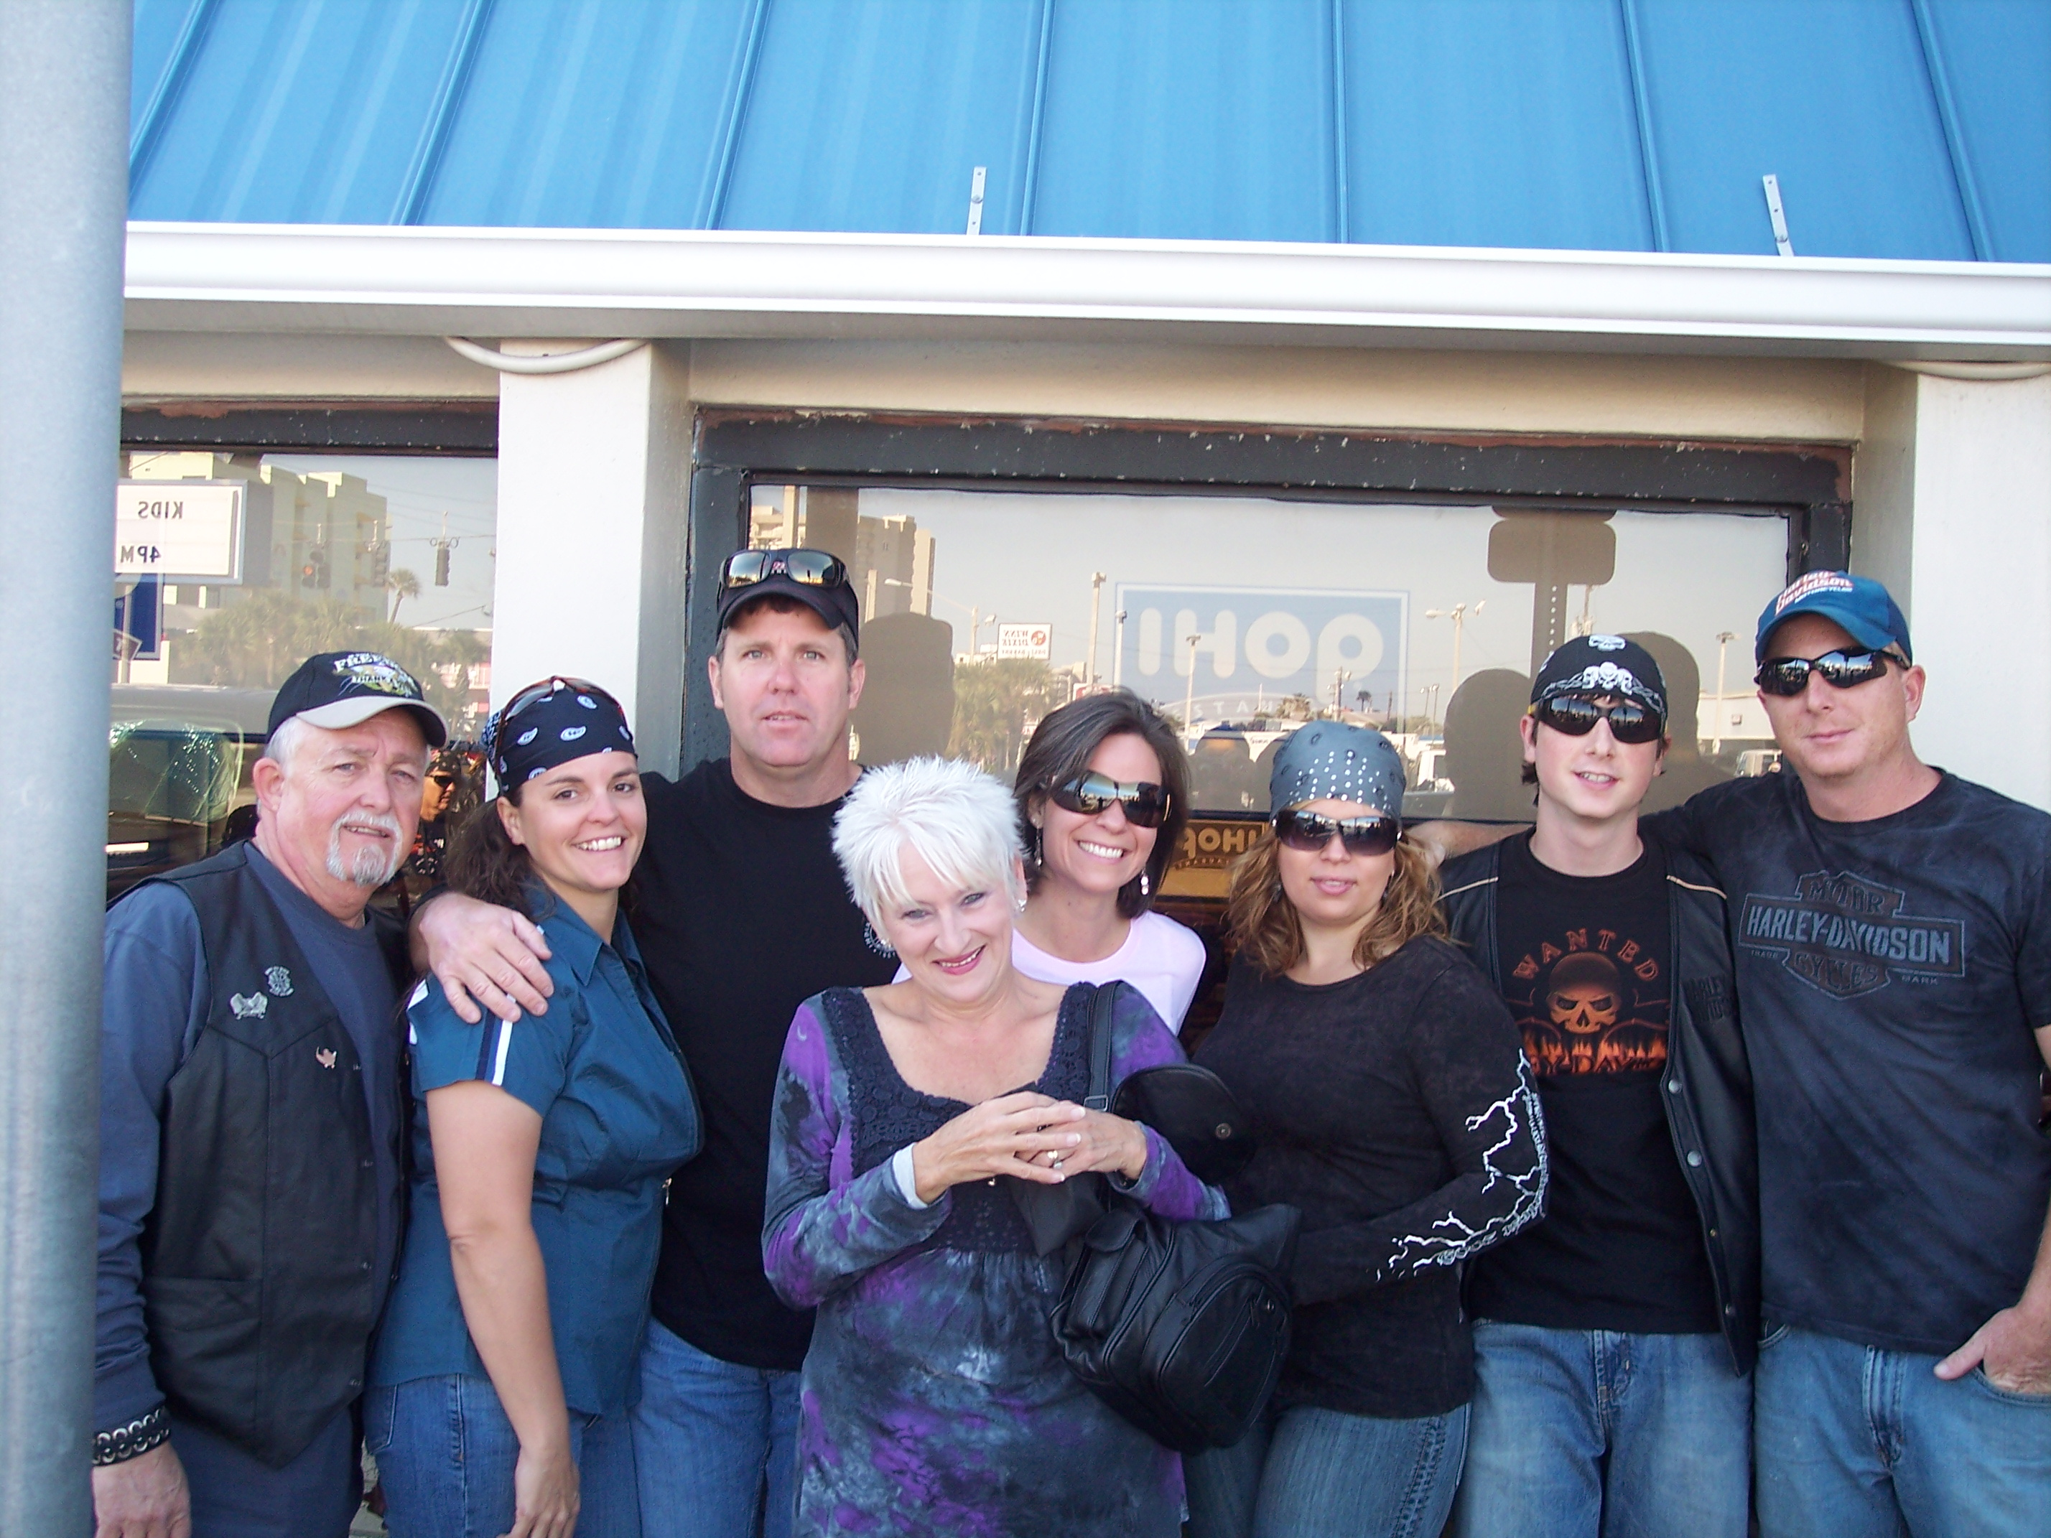

President:
J. Carl Grigg

Vice President:
Jamie C. Grigg II (Lefty)

Secretary:
Jackie Grigg

Treasurer:
Aundria Grigg (LOL)

Road Captain:
SSG Joel Prim (JDawg)

Public Relations Officer:
Kimberly Colesworthy

Sergeant at Arms:
Brad Colesworthy (Big Sexy)

Mission Statement:

The Southern Roots Riders Club mission is to provide every member and guest with an
environment that allows safe, enjoyable, and adventurous riding. The Southern Roots RC will be involved in the surrounding communities and support local Charity events in a way that will promote a positive image of the motorcycle world. It is the goal of SoRo Riders to promote brotherhood and camaraderie amongst those who enjoy the biker mentality & atmosphere in which we ride. Southern Roots RC believes in three Southern principles: God, Family, & Country, and should be the foundation in which to build on.

Officer Duties:

President: To provide leadership and direction to the Vice President and Club Officers. To ensure that all guidelines are followed during club meetings and activities.

Vice President: To Provide Leadership to the Club officers and inform the President and members of all transactions. To schedule monthly meetings and oversee the clubs activities, community involvement, and upcoming events.

Secretary: To ensure that all club activities are conducted according to the club by laws. to keep records of all club meetings and activities.

Treasurer: To record and track all expenses related to club activities and charities. To collect all dues for membership or handle all finances for charity events.

Road Captain: To forward all decisions to Club members of future routes and ongoing changes in upcoming event operations. To provide leadership to entire club for all road marches and map out routes for all events and provide safety guidelines.

Public Relations Officer: To coordinate with other groups for special activities and future events. To handle all community involvement. To form a committee for Charity events and fundraisers. Create any materials needed to promote or advertise club events.

Sergeant of Arms: To provide protection to all members of the club and to ensure that all rules and regulations of the Southern Roots RC are being followed in accordance with the State and Federal laws…ie, helmet, noise, safety equipment, etc. To protect the SoRo Riders and their guest. To keep the integrity of the club and it’s name.

Tail Gunner/Safety Officer: To provide rear safety during rides and watch for disabled bikes during road marches. To prohibit cages from entering formation.

Southern Roots Riders Club Logo

The Southern Roots RC Logo Consist of the three principles in which the club was founded: God, Family, & Country. The first symbol is the Cross. The cross is the focal point for the Christian Faith. God sent his son to die on the Cross. The Cross represents death, rejection, humiliation, rebellion, and submission. Luke 9:23 Jesus said “take up your Cross and follow me”.
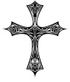
The Celtic Knots is the second symbol. It symbolizes love, honor, and protection. It represents the unity of the family and how they are interconnected with an unbreakable bond. The Celtic Knots represents how God intended the “Family” to be.
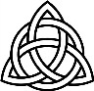
Third is the Skull & Wings. The skull is the symbol of protection and victory over the enemy, used by the military in every conflict since the Civil War. The wings represent Freedom and peaceful journeys. The Skull and Wings represent the protection and freedom that has been given to each of us, the protection of our Constitutional Rights and the freedom of speech.
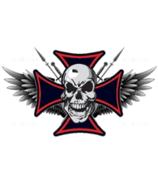

The 8 points of the Maltese cross are said to symbolize the 8 points of courage: Loyalty, Humility, Generosity, Bravery, Glory & Honor, Contempt of Death, helpfulness towards the poor & sick, and Respect for the Church.
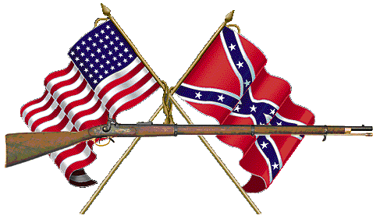The crossed flags and musket represent the countries only Civil War and is a symbol of our Southern Heritage. Therefore, we will be known as Southern Roots Riders Club (RC).
Riding
Together for : God,
Family, and Country!!

